

February 18th, 2016

**Rep Alert – 6003A**

* **Transit case now included, see new model numbers**
* **15% discount on demo model till April 30th, 2016**
* **Get PQ or Energy option for free till June 30th, 2016**

Dear Sales Partner,

Please find below some exciting news on the Fluke Calibration 6003A Three Phase Electrical Power Calibrator.

**Transit case**

As of now, when you order a 6003A, the transit case 6003A/Case will be included. Prices are unchanged!

The case is a hardened plastic case with four unidirectional wheels and foam specially fitted for the 6003A, including a spot for the leads and line cord. This case will help you with transporting the product for a demonstration and it will help customers keep the calibrator safe when shipped for yearly calibration.

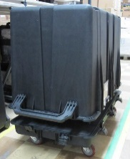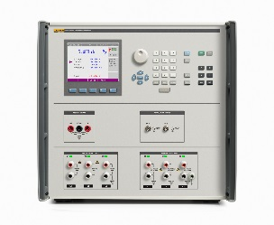

In view of this, new model numbers and oracle codes have been created :



The old oracle codes and model numbers will be obsoleted.

**Distributor promotion**

Demonstrate the 6003A to your potentials customers. With the new transit case you now can easily roll it to the demo site.

**Till April 30th you can order a demo unit of the 6003A T (incl. case) with a discount of 15%.**

**How to order:**

Place your order before April 30th, 2016 with the text **6003A-DEMO** on your order.

**Customer promotion**

Get the PQ or Energy option for free with the 6003A Three Phase Electrical Power Calibrator.

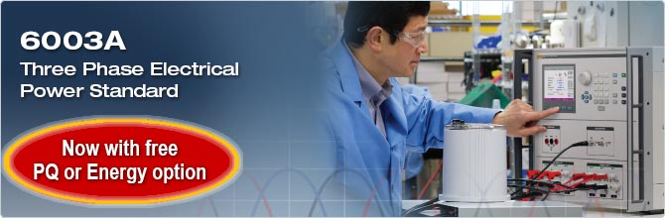**Time frame**:   
February 15th – June 30th, 2016

**How to promote:**

* Promotional webpage and banner on FCAL website:   
  [http://eu.flukecal.com/](http://eu.flukecal.com/free-probe-with-metrology-well)6003a_promo  
  <http://eu.flukecal.com/de/6003a_promo>

****[http://eu.flukecal.com/](http://eu.flukecal.com/free-probe-with-metrology-well)fr/6003a_promo  
<http://eu.flukecal.com/es/6003a_promo>  
<http://ru.flukecal.com/6003a_promo>

* Promotional banner on distributors’ websites.  
  If you need the banner in local language or in a different size, please contact gerda.meijer@flukecal.com
* 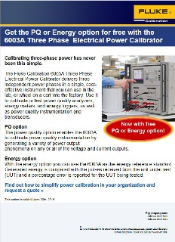Html mail to end customers  
  Please send to you own customer database

### How to order: Place your order as follows :

|  |  |
| --- | --- |
| **Model** | **At the price of the** |
| 6003A/E 115 T | 6003A 115 T |
| 6003A/E 230 T | 6003A 230 T |
| 6003A/PQ 115 T | 6003A 115 T |
| 6003A/PQ 230 T | 6003A 230 T |
| 6003A/PQ/E 115T | 6003A/PQ 115T |
| 6003A/PQ/E 230T | 6003A/PQ 230T |

with the text **PQ-ENERGY-PROMO-6003A**

With kind regards,

EMEA Fluke Calibration Team